Ron Mueck – Scluptor

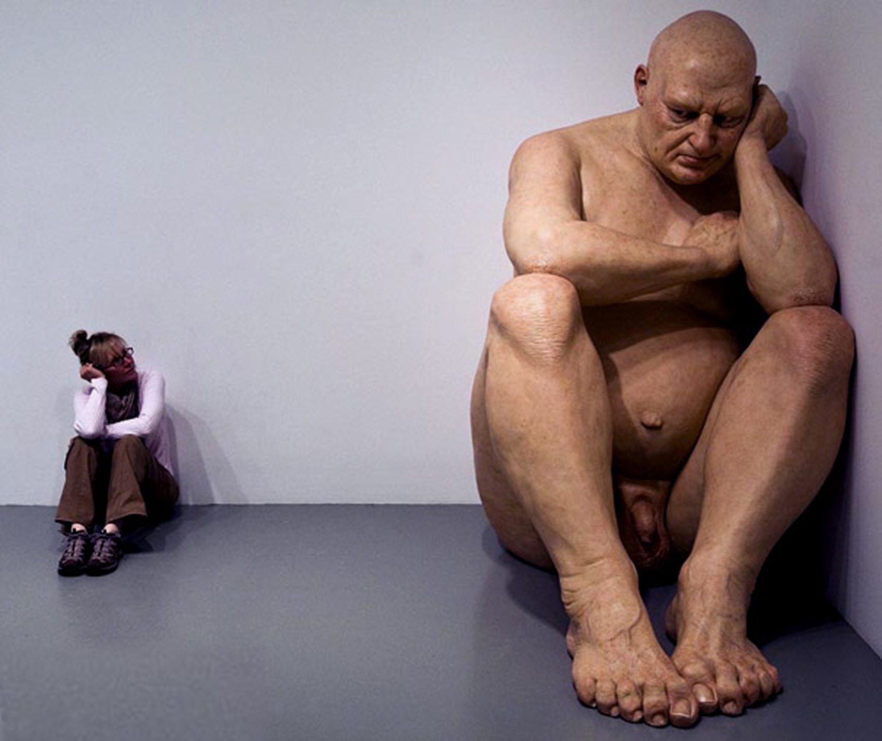
- The Modern Colossus –

Brent A. Polk ⃝ Art 144 ⃝ Spring 2013

Ron Mueck, an Australian native born in 1958 with a completely German heritage started his career creating puppets and costumes as a youth. Muecks’ own parents gave him his inspiration to be the genius he became as they were toy makers themselves. His tinkering with the basic elements of artistic design led him to start his career doing much of the same on an Australian children’s program named Shirl's Neighbourhood on Channel 7 which ran for five years. There he was the creative director and fabricated, voiced and operated the puppets; Greenfinger the Garden Gnome, Ol' Possum, Stanley the snake and Claude the Crow. In the following pages I will describe what I understand as a revival of sorts that are akin to latter day sculptors which had the idea of creating oversized effigies of the human figure. I will also, in some description explain my fascination with what is called “practical effects” in the film industry.
Mueck continued with art of physical design in the film industry and completed major work on the films Labyrinth and The Storyteller a television series by the famed Jim Henson. Mueck transitioned to the creation of photo-realistic animatronic props created for the advertising industry. These mechanical props were made with excellent skill, but were only meant to be viewed in one angle in order to disguise the messy wire workings. As much as Ron enjoyed the creation of these models he wanted to very much to craft something that would be perfect from any angle.
By 1996 Mueck had his own studio and was in the process of a revolution in his career. By now Mueck was in collaboration with his mother-in-law; Paula Rego, constructing miniature (yet life-like) figures for her show. Rego introduced Ron to a Charles Saatchi whom being very impressed my Muecks’ work had immediately commissioned him. Saatchis’ commission led to one of Rons’ most personal and beautiful works named Dead Dad (1996)Fig A.
Dead Dad is a mix-media sculpture of Muecks’ deceased father reduced to one third scale and actually consisted of Rons’ own hair.
Mueck has an interest in using life items in his sculptures. In another early work called Angel (1997)Fig B, Mueck again uses a mixed media approach to sculpt a boy sitting in a stool, in a foreboding pose looking down on the viewer, with wings constructed from actual goose feathers. During 1996-97 Mueck pushed his artistic ability with the creation of a massive work which in itself shows his focus on artistic perfection in recreation with Big Baby (1996-1997)Fig C. With just a witch’s brew of polyester resin, fiberglass, silicone, synthetic hair and an intense control of the air-brush Mueck commands the attention of anyone that questions perfection.
By 1999 Ron Mueck had achieved the position of Associate Artist at the National Gallery, in London. Within the short span of two years Mueck had yet again pushed his creative ability with the creation of yet another group of most gestalt pieces, Mother and Child, Pregnant Woman, Man in a Boat and Swaddled Baby Fig D-G; all during the year of 2002. Not that these weren’t the only “masterpieces” exiting Rons’ workshop, not in the least Seated Woman (1999), Crouching Boy in Mirror (1999–2002), Untitled (Big Man) (2000)Cover Photo, Man in Blankets (2000), Old Woman in Bed (2000), Standing Man (2000) and Mask II (2001-2), were also either in different stages of completion or completed.
Muecks’ 2002 Pregnant Woman sculpture was purchased by the National Gallery of Australia for a round sum of $800,000. Ron Mueck has established himself as a leader in the colossal art department, but he is also well known for the opposite. Mueck has created an array of Diminutive pieces as well including Man in a Boat (2002), Two Women (2005) Fig H, Spooning Couple (2005), Woman with Sticks (2008), Drift (2009) and Youth (2009), all of which are either one third scale like his first “Dead Dad” sculpture or under 12 inches. He has also created much larger work ranging from 9 ft. To 20 ft. Floor pieces i.e. In Bed (2005)Fig I.
All of Muecks’ sculptures bring a new meaning to the word surreal, he is quotes in an interview from ”Sculptor.org” Ref (2) “I never made life-size figures because it never seemed to be interesting. We meet life-size people every day”. I would enjoy a viewing of all his works put together into one show. I can imagine walking through the display starting with the small sculptures place in an under sized room with a solo spot light aimed at the figure. As each work grows in scale so does the space it is displayed in along with the lighting method. I have not actually viewed any of his works in person, but I can appreciate the intense work ethic which goes into these massive and shrunken sculptures. Muecks’ most recent sculptures are just as compelling as any of his past creations, including Wild Man (2005), A Girl (2006), Standing Woman (2007), Drift (2009), Youth (2009) and Still Life (2009)Fig J, all of which are made of mixed media materials. I enjoy “Still Life” the most of Muecks recent pieces. Still Life is a life-like sculpture of plucked chicken scaled to human size and hung upside-down from a hook by its feet. This makes one mortally tied into an intimacy of the death of said fowl.
Ron Mueck is not alone in his craft, many other artists have achieved similar if not better results and fame as Mueck has. There’s Sam Jinks of “Living Masks”, Jamie Salmon Fig K, whose oversized face sculptors might put Mueck skill to shame and Evan Penny. Evan uses silicon as a medium and her sculptures are to be viewed from one angle to be seen properly, any other viewing angle will reveal the distortion she has forced into her work; much the way Mueck started viewing his early creations. There is also Carole Feuerman, Roberto Bernardi and Jason de Graaf. Unlike Mueck; Feuermans’ sculptures are made with the more difficult resin material rather than silicon, this method allows her to focus more on the realism of the anatomy of human form.
Muecks’ oversized works remind me most of the attempts of hyper scale and realism attempts of the past. I recall the Colossus of Rhodes (292-280 BC). A 100 ft. Greek statue built by Chares of Lindos of the Titan Helios placed on upon the grounds of the Island of Rhodes itself. This is one of the Seven Wonders of the World and is a testament to the triumph of mans will to create the impossible. Another gigantic sculptural work from that period would be the 42 ft. Statue of Zeus at Olympia (430-422 BC). Another massive work created by Greek sculptor Phidias, it was a mixed media creation made of plated ivory and gold panels over a wooden framework. These two ancient works set a pace for men to hold themselves up high for others to bear witness to the fear and wonder such a scaled figure can cast. Muecks’ works have this effect on me. I can only feel a fear due to a loss of control I would have if these massive figures were living i.e. St. Vincent - 'Cheerleader' or even the massive puppets in Liverpool. Meucks’ hyper-realistic portrayal of the living form instills wonder as to the frailty and strength that such a juxtaposition of wonder and fright these sculptures emanate i.e. Couple Under Umbrella (2012).
The Statue of Liberty (1886) I would consider the zenith of these concepts as a whole. Standing at one inch over 151 ft. This “sculpture” has a resonance of fear, strength and wonder tied all into one. Frédéric Auguste Bartholdi used ancient yet masterful methods in which to create the statue using the repoussé method. The method Mueck uses might be modern and quite different, but the results are just as effective. Other large scale works such as the Colosso di San Carlo Borromeo, Leonardo da Vincis’ Horse commissioned in 1482 and the German Statue of Arminius, give a glancing chance to allow the world to behold the powers of man and the ability to concur the sky and space.
In concluding this review I would like to consider the appreciation of working with real materials to create the human form at any scale, rather than the 3D software used today to do the same. I myself have much trouble in mastering the translucence of skin, the drape of cloth and hair and the use of anatomical form to breathe life into a character. The work in itself is the manifesto of beauty and the endless consumption of one’s time is the force which cast life into the materials of the artist pallet.

- Reference Page –

1) "11 Sculptors | 50 Hyper Realistic Sculptures." VECTRO AVE Art Design Blog RSS. N.p., n.d. Web. 18 Apr. 2013.
2) "Colossus Of Rhodes." About.com Ancient / Classical History. N.p., n.d. Web. 22 Apr. 2013.
3) "History of The Statue of Liberty." Statue of Liberty — Statue of Liberty History. N.p., n.d. Web. 22 Apr. 2013.
4) "How the Seven Wonders of the Ancient World Work." HowStuffWorks. N.p., n.d. Web. 22 Apr. 2013.
5) "Sculpture.org." Sculpture.org. N.p., n.d. Web. 14 Apr. 2013.
6) All Photo references are from various websites including, but not limited to Google Images and the sited sources.

- Photo References –
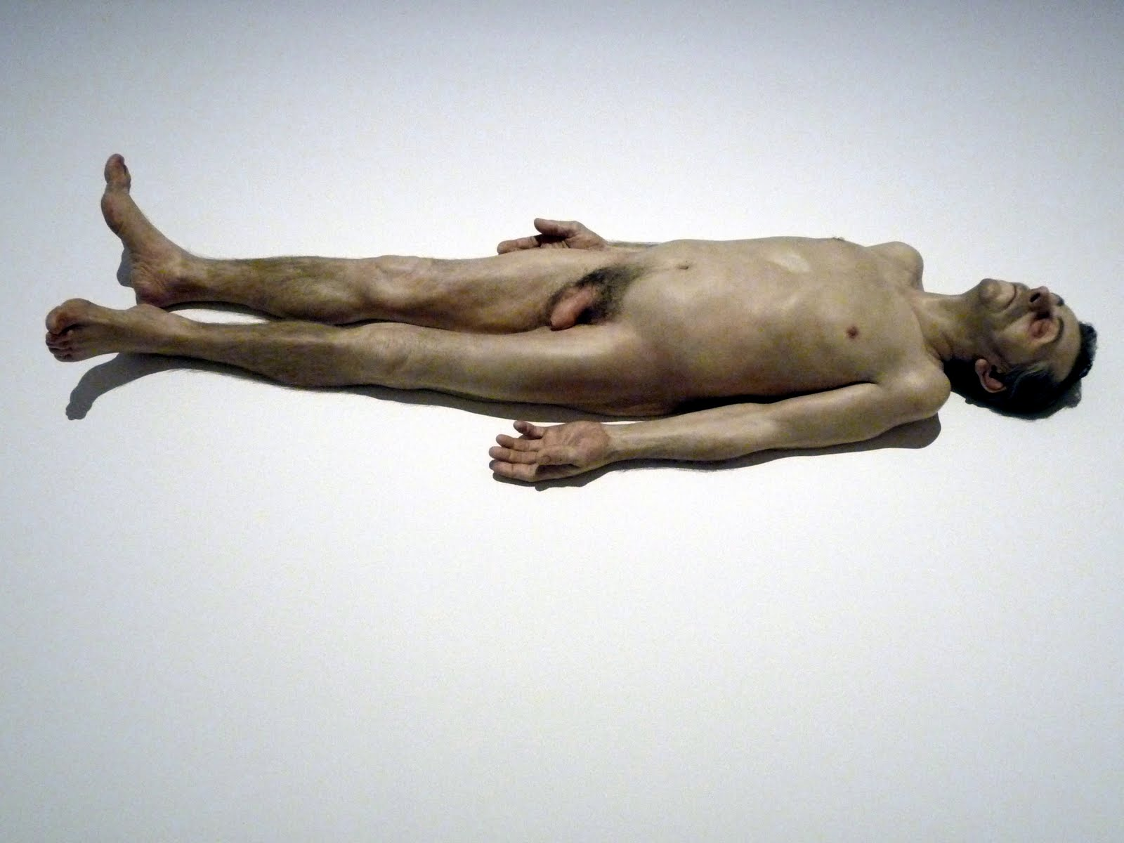
Figure A - Dead Dad (1996–97) Silicone, acrylic paint and human hair - 2/3 life-size sculpture (Stefan T. Edlis Collection, Chicago).
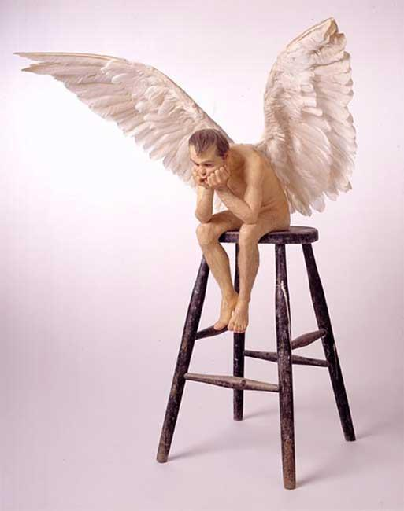
Figure B - Angel (1997) Mixed media - 1/3-scale (Hoffman Collection, Dallas)
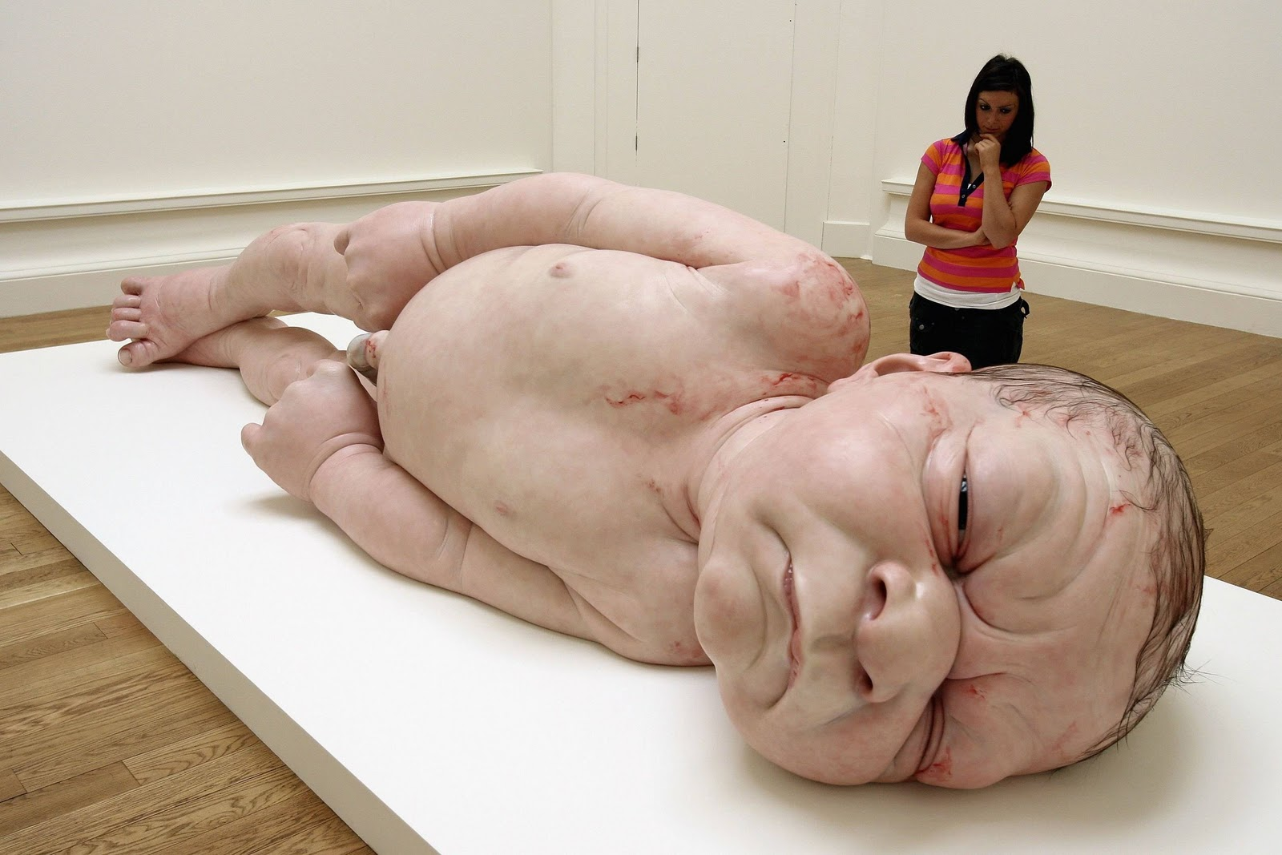
Figure C - Big Baby (1996) Silicone, polyurethane, wood, synthetic hair - 85 cm (Private collection)
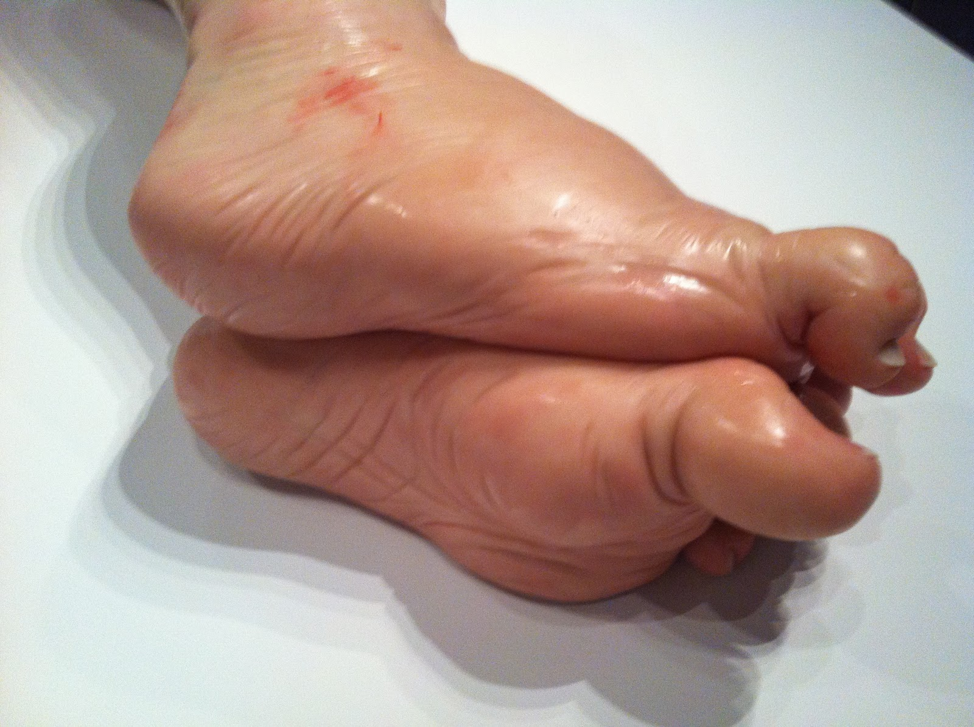
“Big baby” Detail of feet.
Figure D - Mother and Child (2002) Fiberglass, resin, silicone - ½ Scale (Bayerische Staatsgemaeldesammlungen, Munich)
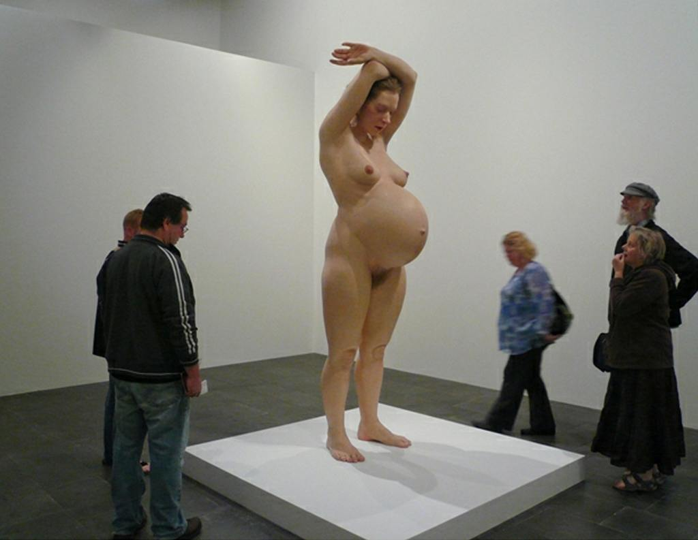
Figure E - Pregnant Woman (2002) Fiberglass, resin, silicone - 2.5 meters (National Gallery of Australia).
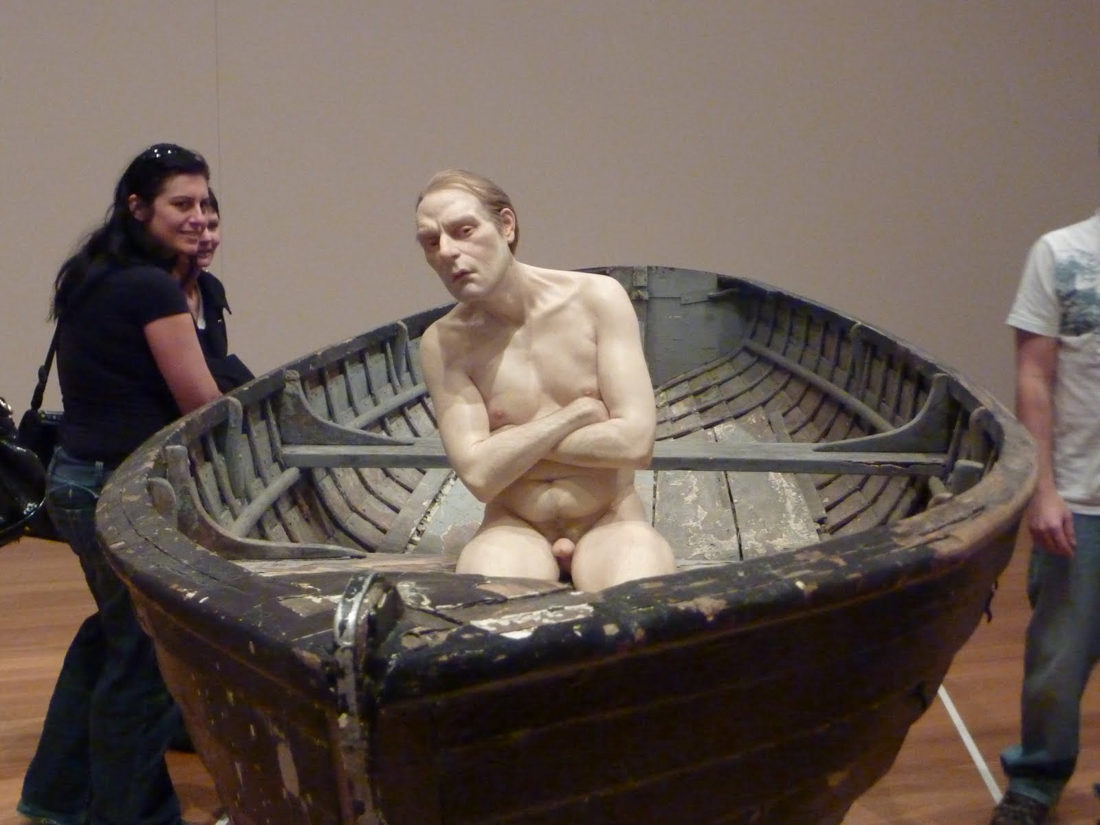
Figure F - Man in a Boat (2002) Mixed media - 1/3 scale (Private collection)

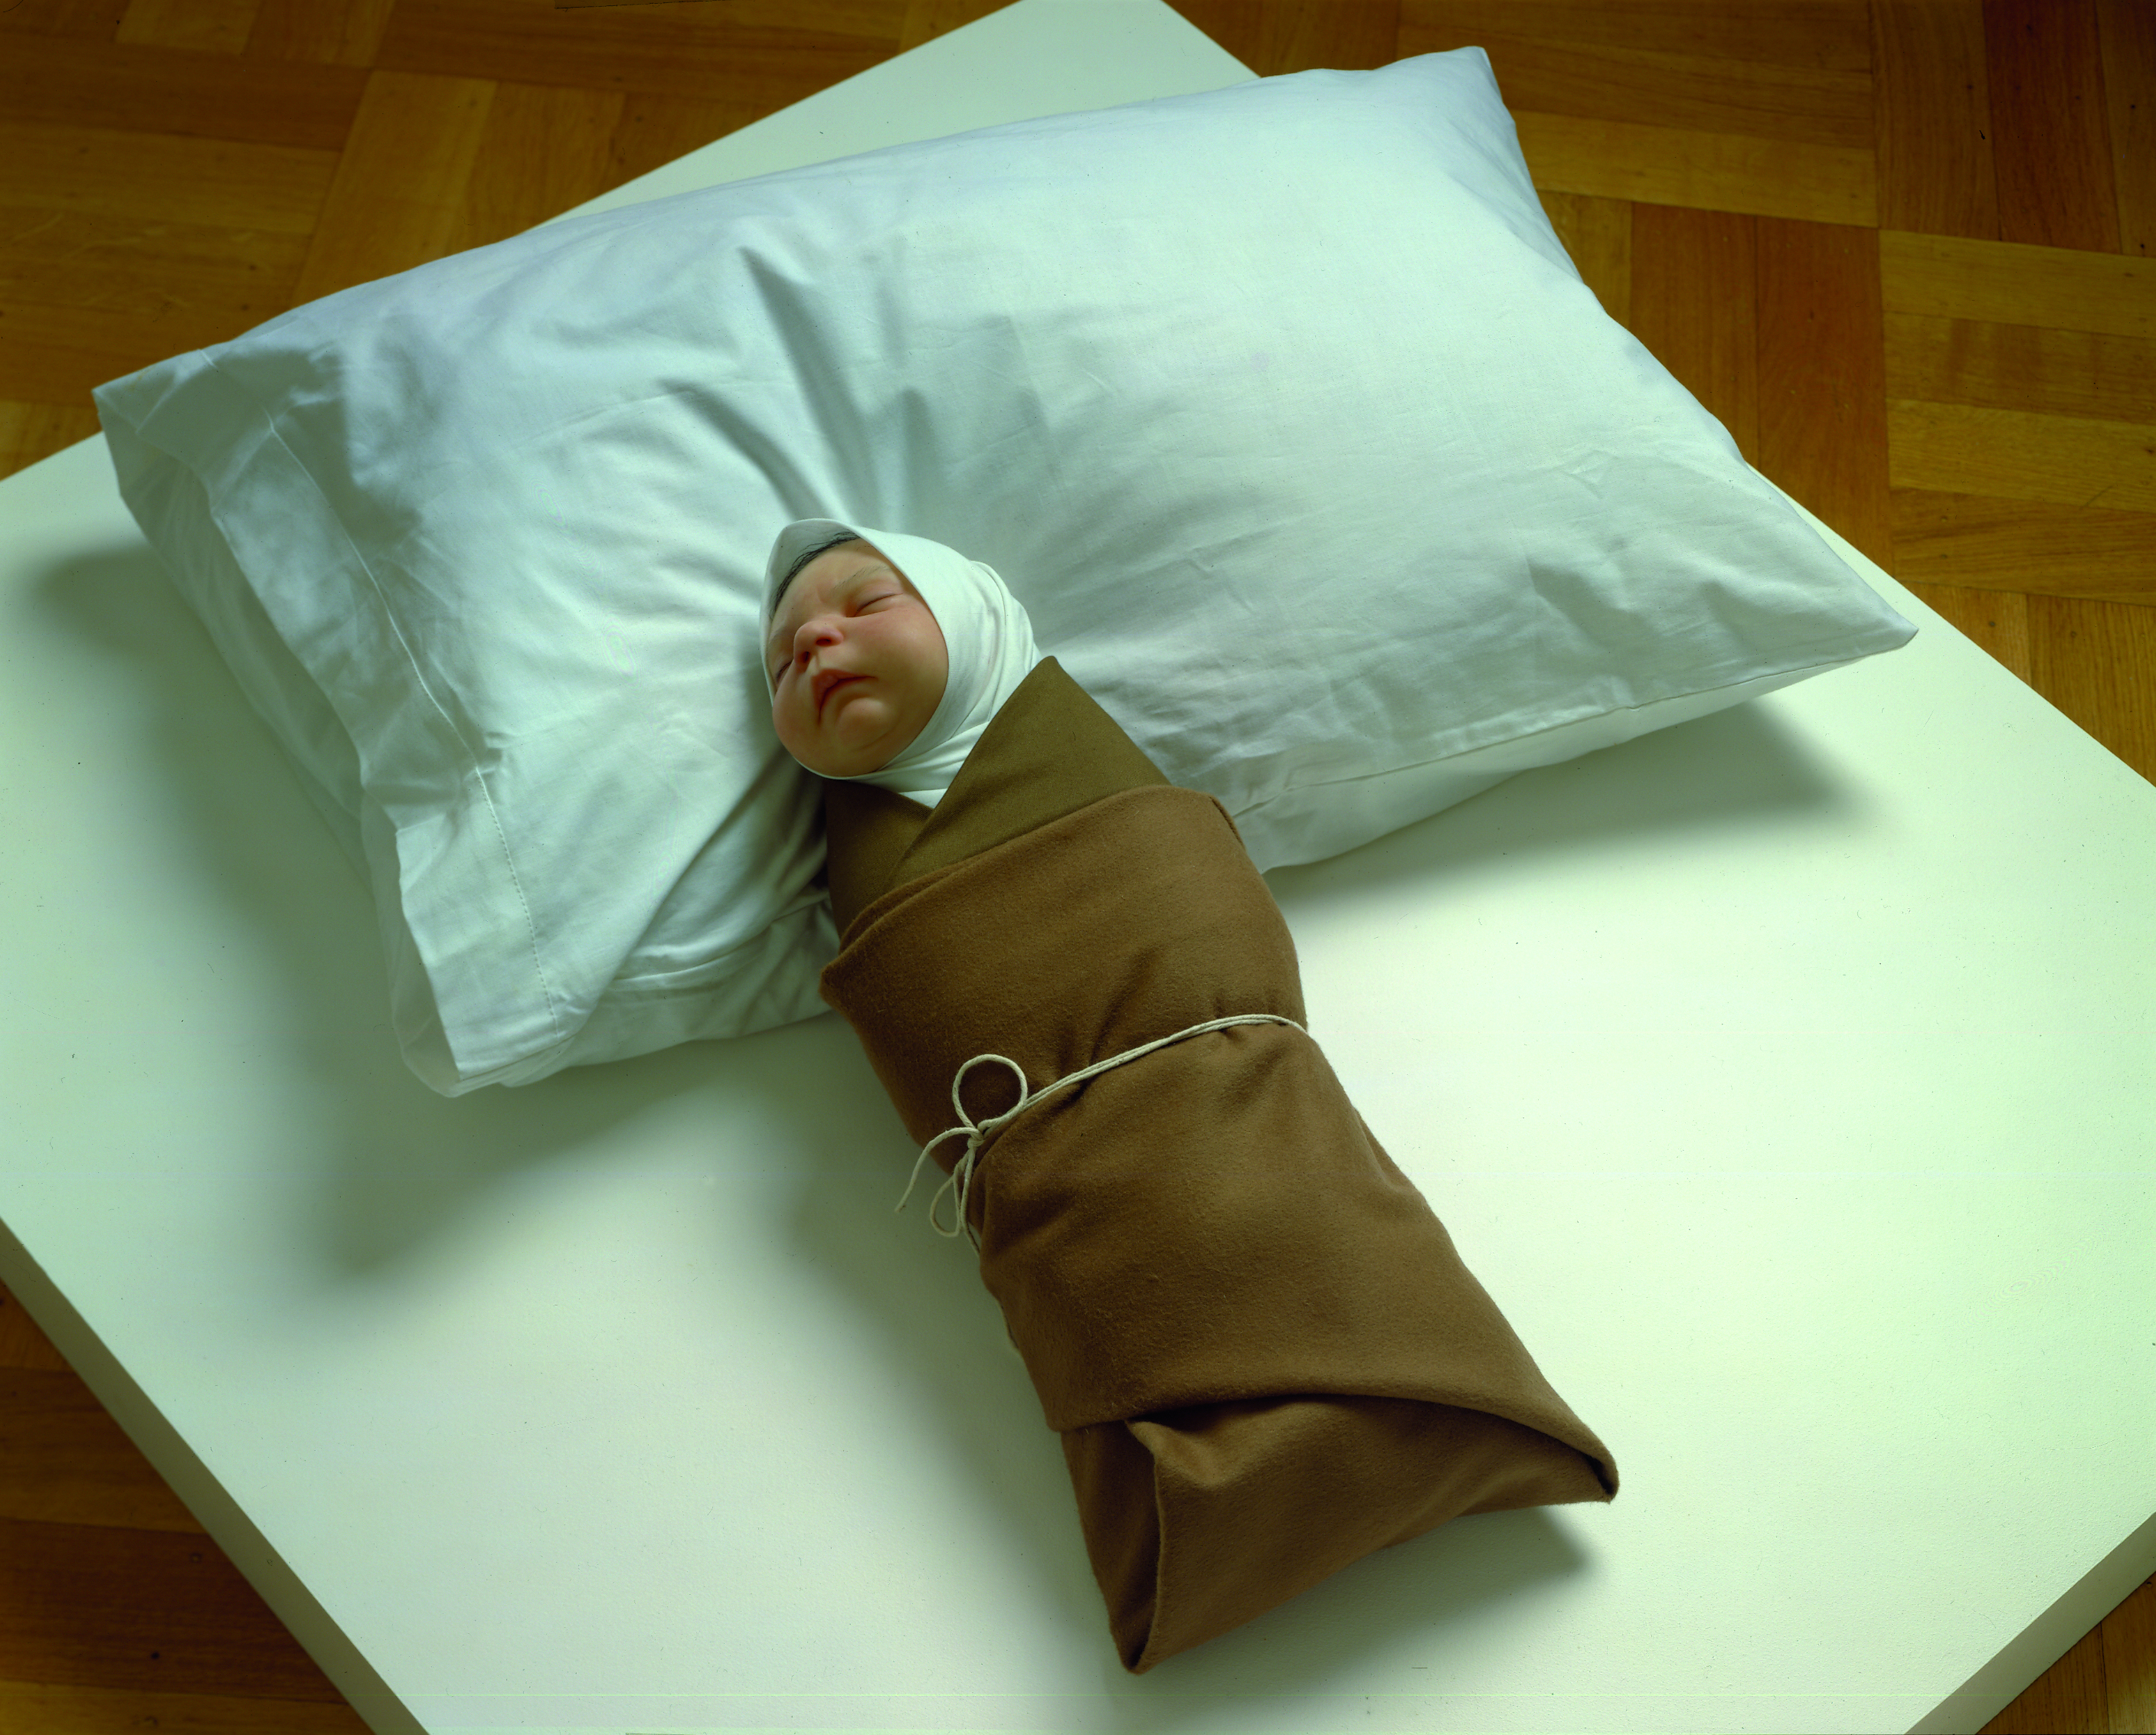

Figure G - Swaddled Baby (2002) Mixed media - life-sized (Unknown Location)
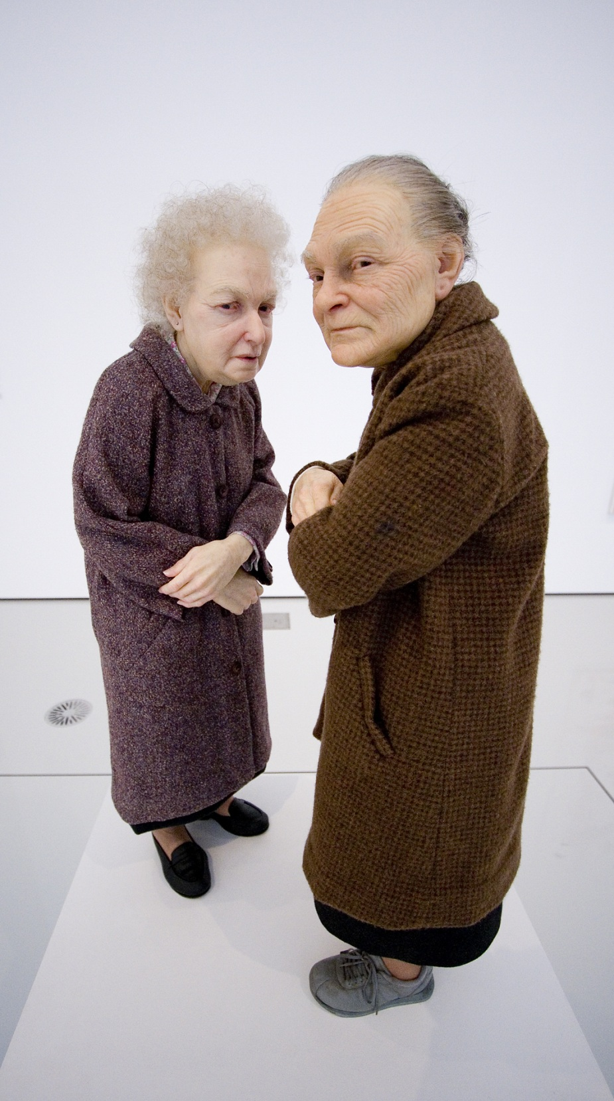
Figure H - Two Women (2005) Mixed media - 50 cm (National Gallery of Victoria, Melbourne, Australia)
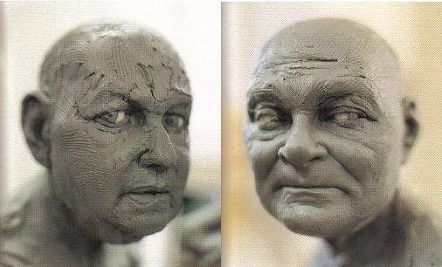
“Two Women” WIP (Work In Progress)

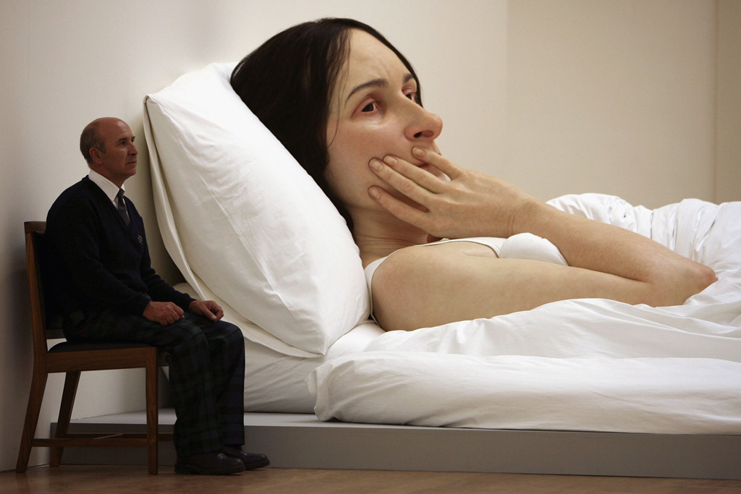
Figure I - In Bed (2005) - 30 Ft. (Queensland Gallery of Modern Art)
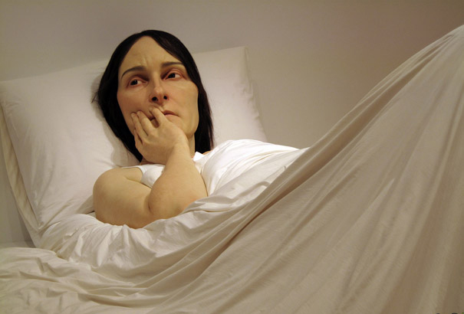
“In Bed” (Detail photo)

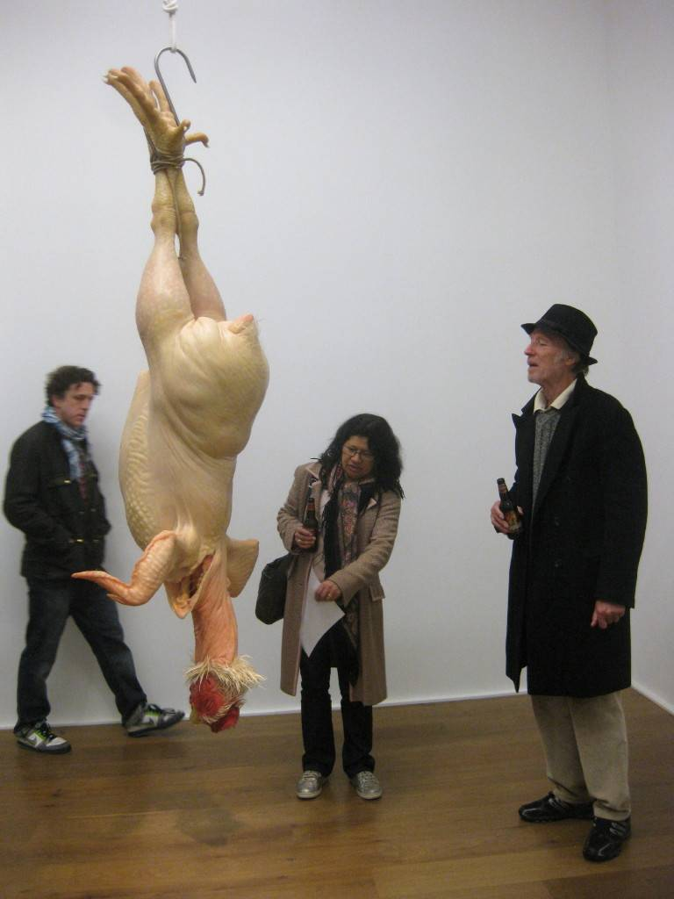
Figure J - Still Life (2009), mixed media (Anthony d'Offay)

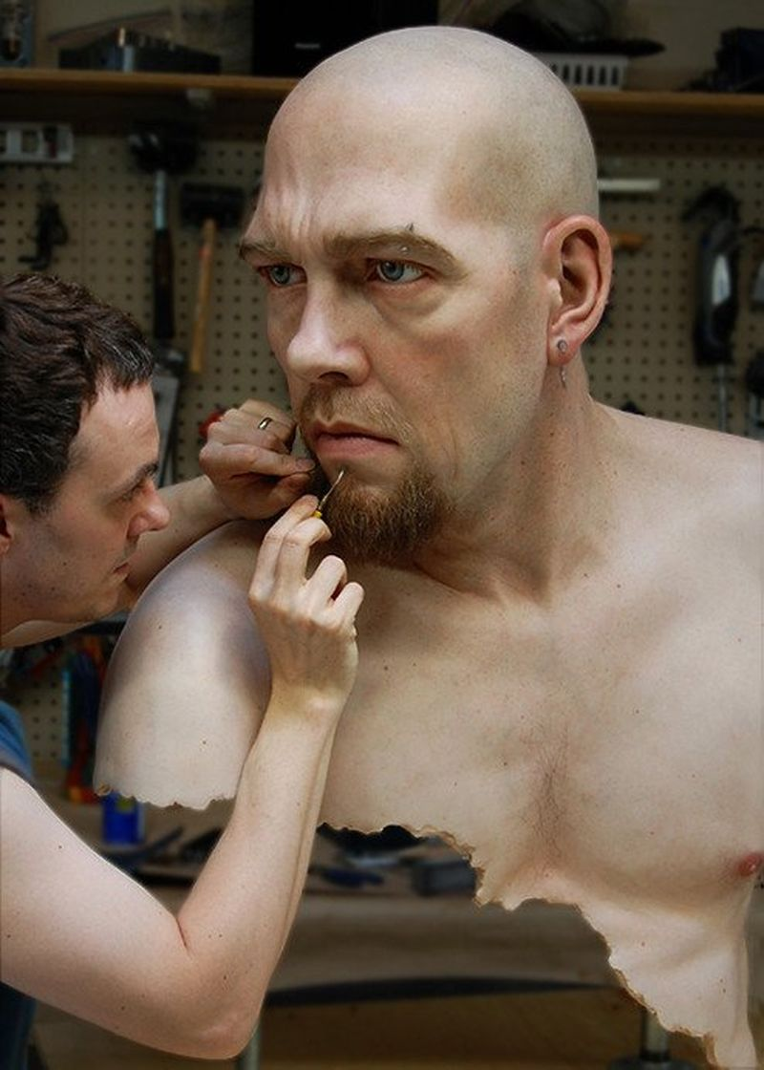
Figure K - Jamie Salmon “Living Masks” (WIP)

- Unlisted Figures by Ron Mueck –
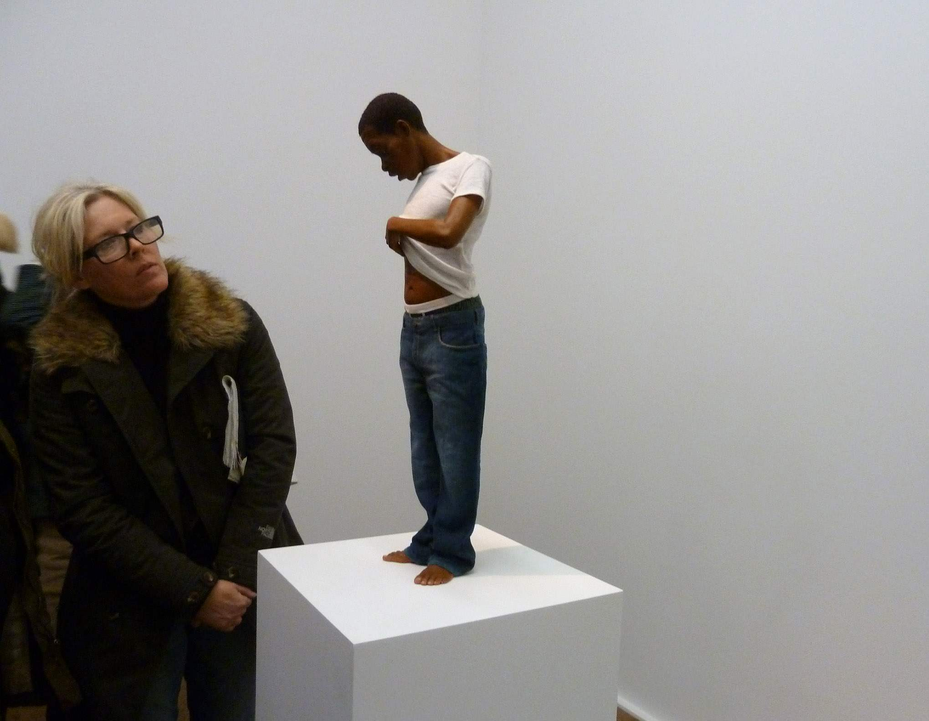
Youth (2009) Mixed media - 65 cm (Anthony d'Offay)
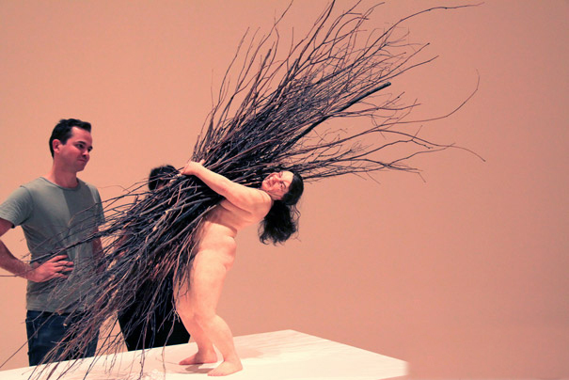
Woman with Sticks (2008) Mixed media - 180 cm (Private collection)
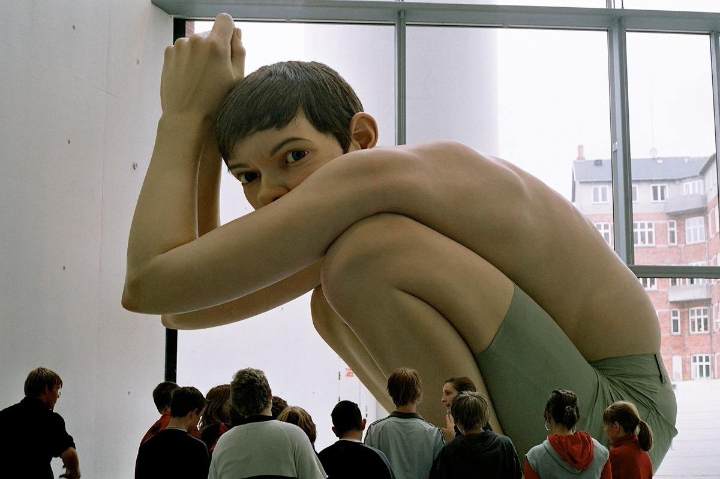
Boy (2000) Fiberglass, resin, silicone - 15 Ft. (Art museum AroS)

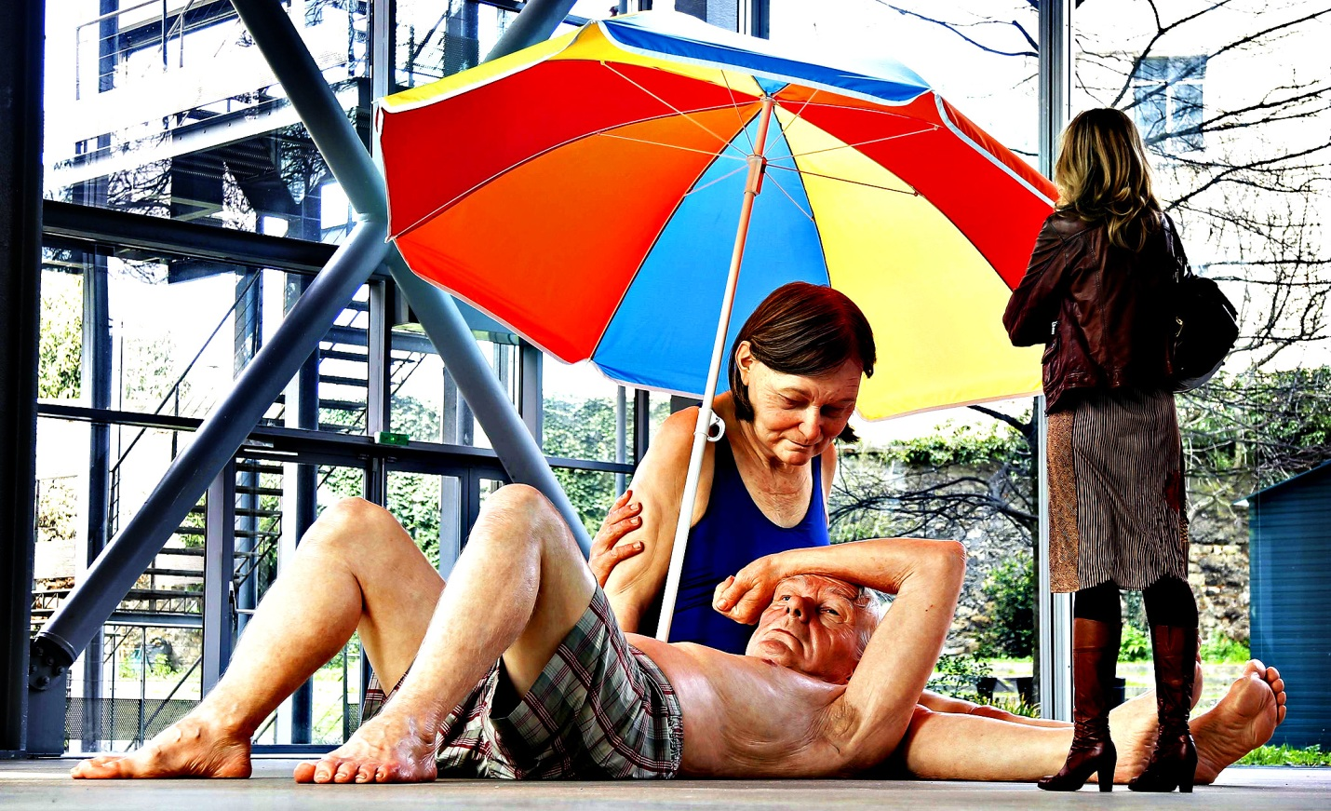
Couple Under Umbrella (2012) (Unknown location)

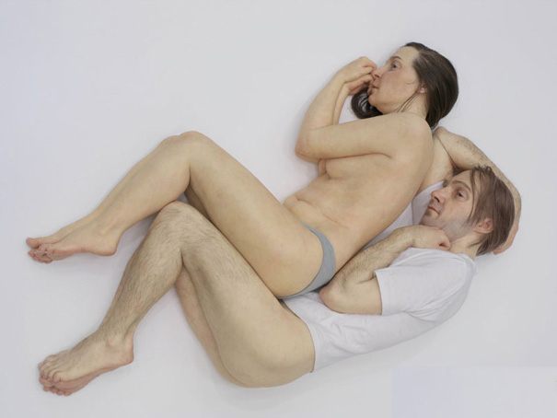
Spooning Couple (2005) Mixed media -1/2 scale (Unknown location)

