Maya Lin

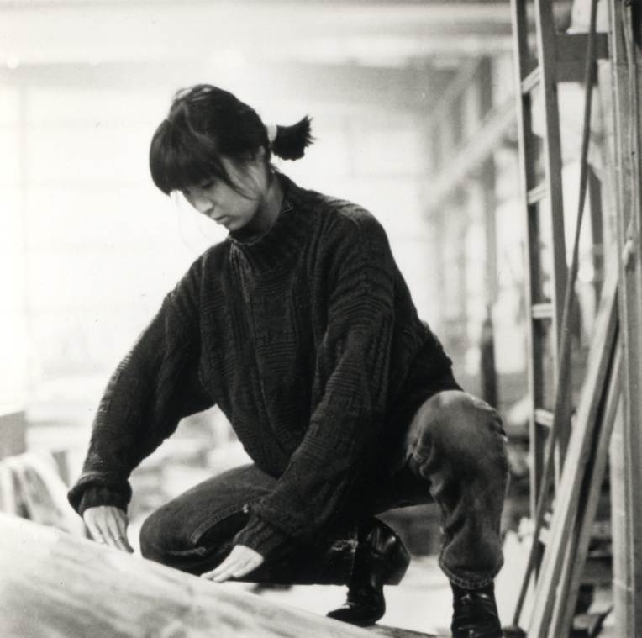

Strength and Adversity

Brent A. Polk
Art 145
Fall 2013
Maya Lin’s fame began when she was a mere 21 years old. When her and some of her fellow students decided to enter into what would become one of the most scrutinized and controversial public works of open sculpture in American history. Lin’s family entered into the United States from leaving China just before the communist takeover in 1949. Resettled in Ohio, both her parents (who were artists themselves and Lin is quoted as saying “we eat from my father’s bowls”) became professors at the Ohio University. At the tender age of 21 Lin, a student at Yale, designed the “Vietnam Veterans Memorial” 1981 Washington, D.C. (Fig.1) as a class project, entered it into what had then become the largest competition in US history and actually won. Lin’s design was simple, cutting edge and actually placed high the goal of listing all 58,272 soldiers that died in the war. Maya’s concept won over 1,441 other competitors and then the crisis began. Being of Asian descent did not loosen up the American people to her design being chosen and many individuals and rally groups including politicians in high offices were not pleased with her plan for the Vietnam memorial. After Lin’s appearance at a press conference which coincided with the final panel vote deciding her fate. After the proposal was finally passed for construction, the ugliness of her treatment continued by her name not being mentioned during the memorials dedication.
This is an example of what has given Maya Lin a special ability to design for the people. Maya Lin’s political popularity was an asset when she was commissioned to create over to a dozen other works across the country and reaching into global arenas as well. She was the designer of the “Peace Chapel” at Pennsylvania's Juniata College, the "Women's Table"(1990–93) at Yale University (Fig.2), and the Langston Hughes Library for the Children's Defense Fund in Clinton, Tennessee. Her next political hurdle was the design of the “Civil Rights memorial” (1988–89 in Montgomery, Alabama (Fig.3). Lin’s concept of using a black circle of stone with a chronology of dates spiraling to the edge of the disc with a thin layer of water slowly falling off the edge was a stunning design to say the least and was welcomed with open arms by the African American community.
Lin’s works are both diverse, visually engaging without being overwhelming and humanly striking. She has the artistic ability to draw one straw of clarity and use it to focus ones attention on what she desires you to witness. In her earth work “Wave Field” (1993–95) University of Michigan(Fig.4) she has captured, by using rhythmic shapes; a sense of sprite or soul in the inanimate substrate of the land. Being an Architect by trade allows Lin to utilize an innate comprehension of form and space. Her many works show this method over and over again.
Maya Lin’s direct influence on arts relationship to society was documented in an Academy Award winning film based on her early work named Maya Lin: A Strong Clear Vision, released in the mid-nineties. It tells her story of strength and adversity through the time she was a student into her Masters of Architecture from Yale University in 1986 until her installation at the Pennsylvania's Juniata College. A stirring retelling of what Lin’s was put through after her design was chosen for the Vietnam Veterans Memorial starts the film, then slowly flows her life to tell both a story of inspiration and dedication for creating moments that stir her audience. The San Francisco Citizen is quoted “Lin’s extraordinary ability to convey complex and poetic ideas using simple forms and natural materials is fully evident in Systematic Landscapes. Working in a scale that relates to the land, and combining a deep interest in forces and forms of nature with a long-term investigation into the possibilities of sculptural form to embody meaning, this exhibition offers a rich, immersive experience for visitors that brings the sensory understanding of Lin’s outdoor works inside.” This statement I cannot argue with. Maya Lin somehow has fused the line with the mind’s eye in a way that allows you to look past what you are witnessing and actually fell what Lin is attempting to convey.
Maya Lin has continued to create many moving works of art including “Elapsed time”1995 Long island Railroad, Pennsylvania Station; “Ecliptic” Frey Foundation, Grand Rapids, MI, 2001; “Eleven Minute Line” Wanås Foundation, Wanås, Sweden, 2004; “Above and Below” Indianapolis Museum of Art, Indianapolis, IN, 2007; “ Pin River” 2008 Yangtze, China; and finally “What is missing” 2012 Internet. The last project was nothing less than a collaboration with numeric data and the human response to our continual negligence and mindless destruction or our star ship Earth. I have included a Web Link to this online work.
I do not have the space to completely list all of Maya Lin’s work, but I have done my best to both describe what it is I admire about her art works and the ability she has to engage her public into what I can only express as a hypnotic state of rhythm and sense and feeling.
In closing, I can only say that what I admire in Maya Lin is her inherit vision that somehow blends the visual form with the subliminal message. To see and then consciously understand an emotional goal is quite a talent indeed. To quote Maya Lin herself in regards to her art” You read them like books, out in public. They ask you respond one-on-one.”

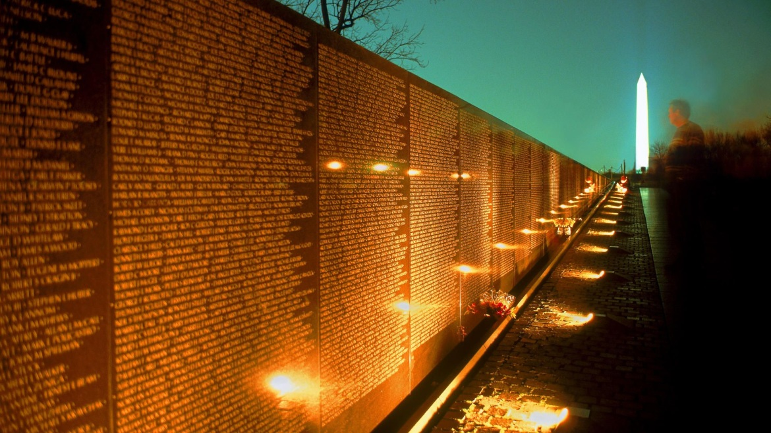
(Fig.1) Vietnam Veterans Memorial.

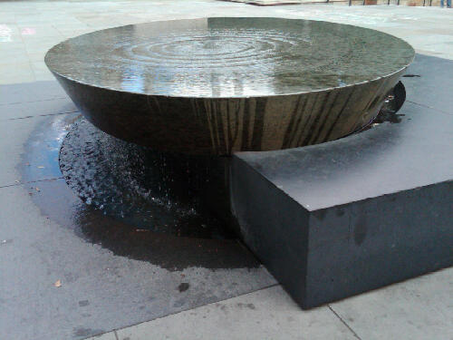
(Fig.2) Women's Table.

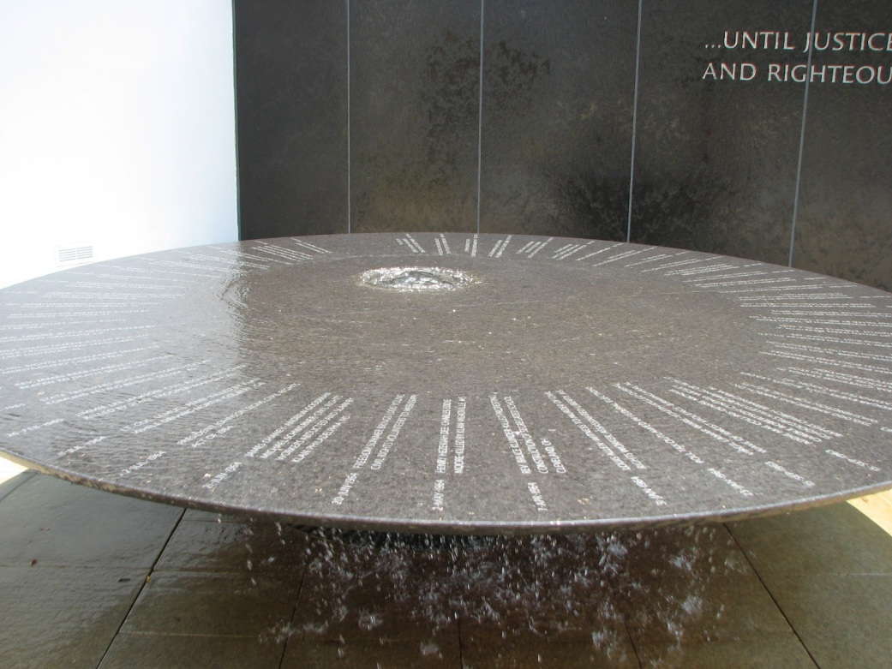
(Fig.3) Civil Rights memorial.
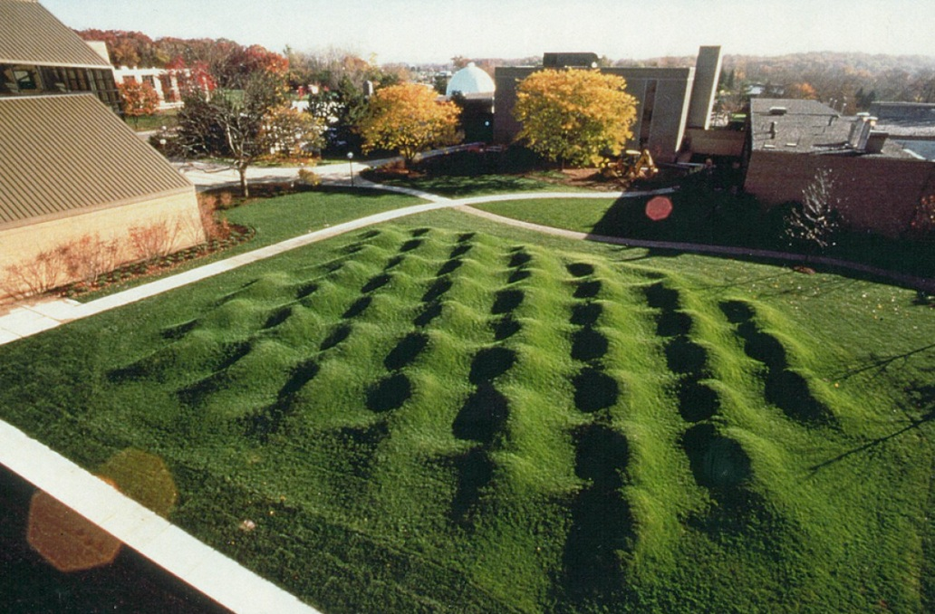
(Fig.4) Wave Field.

Resources:
- "Projector." Projector. N.p., n.d. Web. 21 Nov. 2013.
- Brown, Patricia Leigh. "AT HOME WITH: Maya Lin; Making History On a Human Scale." The New York Times. The New York Times, 21 May 1998. Web. 21 Nov. 2013.
- "Maya Lin Interview." -- Academy of Achievement. N.p., n.d. Web. 21 Nov. 2013.
- "San Francisco Citizen." San Francisco Citizen. N.p., n.d. Web. 21 Nov. 2013.

